2. Modul
Trump reelection campaign 2020 directed towards American-Indians
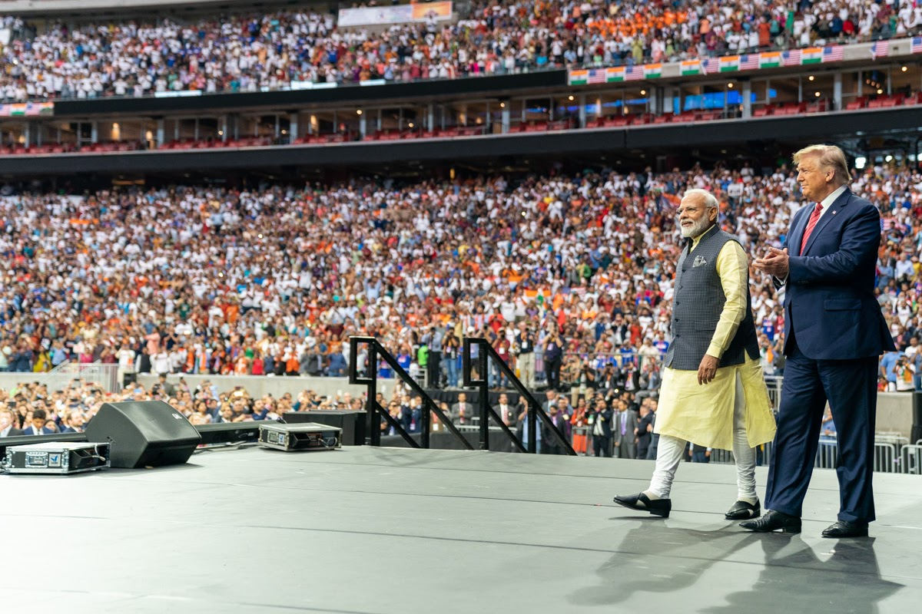
During the US election 2020, a campaign advert specifically targeted towards Indian-Americans was released. It referred to the bond between India and the USA and featured images and quotes from events where the two leaders had visited each other. Modi first visited Trump in The White House in 2017, and later again in 2019 in a stadium event in Texas dubbed “Howdy Modi”. In February 2020, Trump visited Modi in Ahmedabad, India, at the event called “Namaste Trump” and talked about the strong bond between the nations and the “four million amazing Indian Americans all across our country”.

The campaign video uses the slogan ‘Abki baar Trump Sakaar’ which is Hindi for ‘Once again bring Trump to power’. In 2020, an estimated 1.3 million Indian-Americans were expected to vote in the American election.

Before You Watch
- Analyse the rhetorical/communicative situation of the campaign video:
  - What is compelling the Trump campaign to make and release this video, and (briefly!) who is Trump?
  - Who is the intended target audience who can help Trump get reelected?
  - What are some challenges and advantages for Trump in this rhetorical situation, and how should he address these constraints? E.g. what rhetorical devices does this situation call for?
- Who is Kimberly Guilfoyle, and what is her relationship to Donald Trump?

After You Watch
- What role does Kimberly Guilfoyle’s tweet play in the beginning of the video?
- Comment on the cinematic effects. You could include the following:
  - Comment on the music in the campaign video. How would you characterize it? And what effect do you think is it meant to have on the viewer?
  - How are slowmotion and pan used for effect?
- What role does Indian Prime Minister, Narendra Modi, play in this video?
- Comment on the choice of language (words and phrases; language features; and sentence forms) in the quotes from Trump’s speech to Modi:

“America loves India. America respects India. And America will always be a faithful and loyal
friend to the Indian people.”

“We have come to know the splendor of the 4 million Indian-Americans. They are truly
spectacular people.”

“Thank you all for the contributions you have made to my beloved country.”
- Why do you think there are so many shots of huge crowds cheering? What effect do you think this has on the intended audience? What effect does it have on you?

