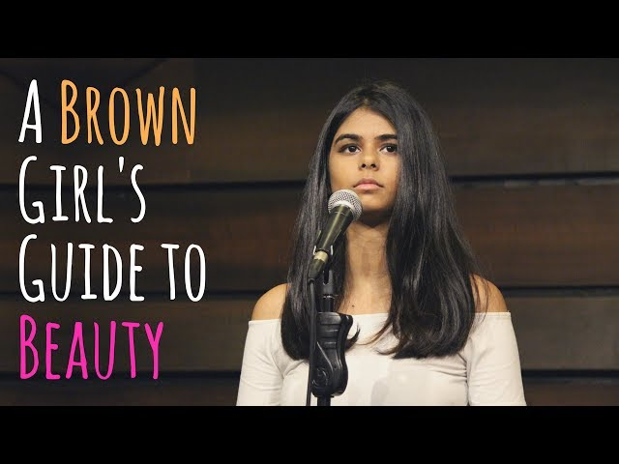
A Brown Girl’s Guide to Beauty

Aranya Johar

Since the age of 9 I’ve been slapping my face
with fairness creams
Every face wash was a slap in the face
Because I was a skin tone which was … ugly
My chest was too small for a girl who just hit puberty
And my skinny waist and unhealthy thigh gap
was the only thing I wore confidently around
I had a voice and opinion
Byt they muted my sound
Probably because I was told,
Boys only like girls who are … fair and lovely

My cousin brother starving himself
Because skinny abs were easier to obtain than a healthy diet
He read about actors doing juice diets
and decided he wanted to try it
All because there wasn’t a single GQ or Man’s World
That didn’t have abs embossed
We forget that beauty for men
Also comes at a cost
And I’d ask for a penny for your thoughts
But I heard being healthy is wealthy
And it’s both we’ve lost

I am the colour of the strong fragrant tea
Aunty sips while nonchalantly remarking:
“Bipasha would be prettier if she was fair”
The colour of our skin dictates our beauty
And that’s not the only thing’s that unfair
When we brown girls revolt
Against our own reflections
Every single time an Indian magazine puts a light-skinned girl on the cover,
Calling her brown
I ask my mother to get me haldi,
Yellow paste over yellow paste…
… because anything is better than brown,
Anything is better than dark
Only the light skinned with European features
Are considered art

My friend’s face is covered with cream
More than his girlfriend’s kisses
He flinches every time she says
She accepts him for his true colours
How do I teach him to embrace the colour of his skin
When she keeps gifting him fairness creams?
His daily baptism with sunscreen
To protect him from sun tans
Men lathering themselves with the same
behind closed doors…
… because apparently being insecure
makes you less of a man

When I was asked to be an ideal body type,
I was taught
They want the curvy chick
But not the cellulite
They want the big butt
But not the thick thighs
They want the talk small
But the waist smaller
They want the heart big
But the chest bigger
And often women of gender
Reiterate these thoughts
But you see,
It’s internalized
It’s what we’ve been taught

So I ask my Ma…
Instead of looking for grooms who are fair,
Let’s look for grooms who treat people fairly
Because the colour of someone’s skin
Isn’t what we should consider when we look to marry
Virtues, beliefs, opinions and decisions
Scale larger than his stand on a fairness scale
Forget snow white,
Say hello to chocolate brown,
I’ll write my own fairytale.

There isn’t a single person who
Isn’t pulled apart by these expectations,
Brown girls struggle getting the right foundation,
Boys constantly doing weight calculations,
We’re all more than our
Coloration and body types,
‘Cause you and I,
We’re all alike.

With the hope of being able
To some day love another
Let’s begin
by being our own first lovers
Because people aren’t made
to fit or custom-made,
It’s time we realize
Love comes in all shapes and shades.
It’s time we loved,
All shapes and shades.

