1. Modul
Trump and Modi – rhetorical criticism (links to videos on narratingindia.org under ‘Ambition’)
As a display of friendship and strong diplomatic relations between the nations, prime minister of India, Narendra Modi, and POTUS, Donald Trump, have visited each other at major public events. Modi’s visit in the USA in 2019 took place in Texas, and the event was dubbed ‘Howdy Modi’ and drew a crowd of around 50,000 people from the Indian diaspora. In February 2020, Trump visited Modi in Ahmedabad, India, at the event called “Namaste Trump”.

Before You Read and Watch
- Comment on the titles of the events, “Howdy Modi” and “Namaste Trump”. What are the connotations of more informal titles like these?
- In terms of rhetorical constraints, what are some of the things that leaders should be aware of when visiting each other? What are the dos and don’ts?
  - What should the host be aware of?
  - What should the guest be aware of?
- Do some research. What are some of the ideas and slogans that Modi and Trump used in their respective election campaigns? Any similarities?
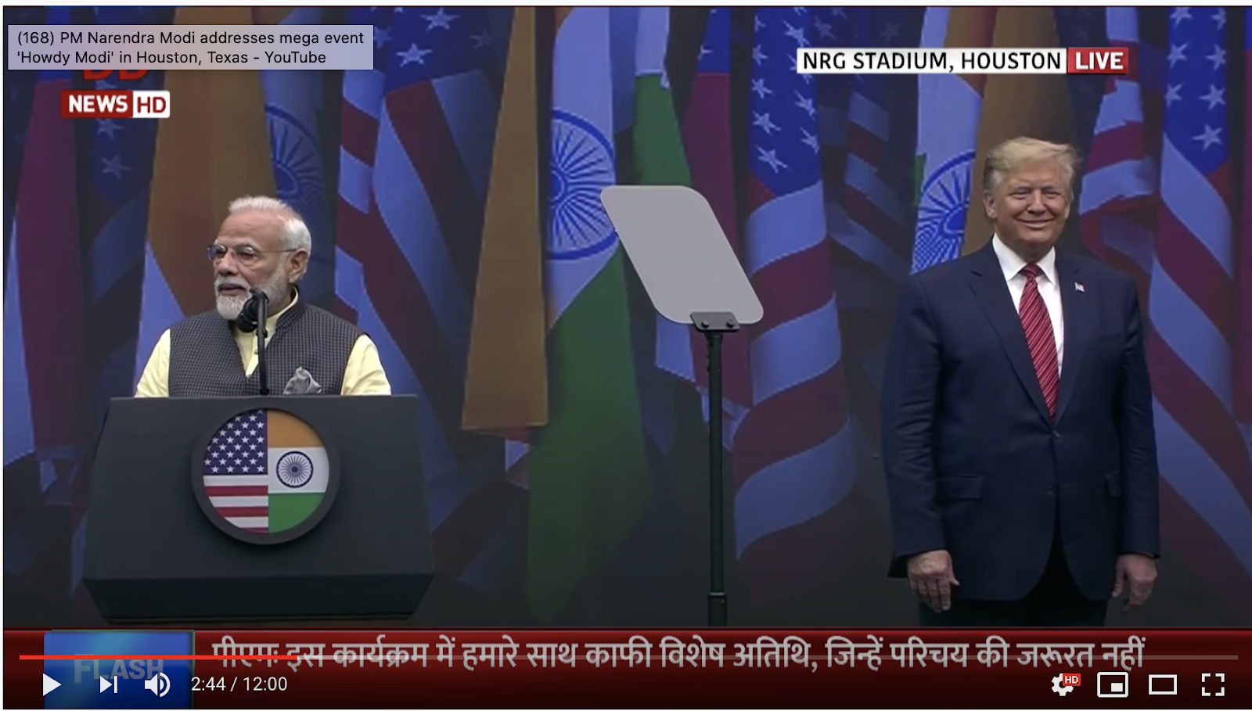
“Howdy Modi” rally – Houston, Texas
- Comment on Modi’s introduction of Trump.
- How does Trump address the Indian Americans?
- How does Trump describe the relationship between India and the USA?
- What are some of the achievements of the Indian American community which Trump describes?
- What seems to be the purpose of Trump’s speech? Substantiate your answer with examples from the speech.

“Namaste Trump” rally – Ahmedabad, India
- Comment on how Trump describes India’s development. Find some examples.
- Comment on the quote: “There is all the difference in the world between a nation that seeks power through coercion, intimidation, and aggression, and a nation that rises by setting its people free and unleashing them to chase their dreams. And that is India.” What is the point of bringing up these contrasting forms of governing?
- Trump quotes Swami Vivekananda and goes on to say: “In America and in India, we know that we are all born for a higher purpose: to reach toward our fullest potential, to work toward excellence and perfection, and to give all glory to God.” What is the point of using religious/spiritual references like these?
- What seems to be the purpose of Trump’s speech? Substantiate your answer with examples from the speech.

